Exploratory Data Analysis Report
UK Crime Analysis for Real Estate Decision making

Executive Summary
This report presents an exploratory analysis of crime patterns across four UK police force areas: Metropolitan Police Service, West Midlands Police, North Yorkshire Police and Dyfed-Powys Police. Using police open data from 2024–2025, crime trends were analysed by region, crime type, geographic distribution and time, with population adjustments applied to allow fair comparison. The analysis found that urban areas experience higher crime rates than rural regions, with violence and sexual offences being the most common crime category. Clear seasonal patterns were also observed. Based on these findings, the Metropolitan Police Service and Dyfed-Powys Police are recommended for further investigation to support real estate investment decision-making.

Introduction
This report presents the exploratory analysis of crime patterns across four selected regions in the UK, these include: Metropolitan Police Service, West Midlands Police, North Yorkshire Police and Dyfed-Powys Police. The analysis was conducted for Nadine Green, Head of Sales at a real estate company, who requires insights in crime trends to aid her property investment and sales decisions.
Understanding how crime levels vary across regions can help identify areas that may be more or less desirable for real estate development. The analysis focuses on identifying differences in crime rates, crime types as well as the geographic distribution across the selected police forces.
The regions selected allow for a useful comparison between rural and urban environments and how they may trend differently. The objective of this analysis is to identify key patterns in the data and how they can inform sales decisions – two police forces will be recommended for further investigation.

Dataset Overview
The analysis is based on street level crime obtained from the UK Police open data platform. The dataset contains records of all crimes reported across each of the police force areas. It includes the type of crime, the location coordinates and the month the incident occurred.
For this analysis, crime data from four police forces were selected: Metropolitan Police Service, West Midlands Police, North Yorkshire Police and Dyfed-Powys Police. These were chosen to provide a comparison between urban and rural areas, the Metropolitan and West Midlands areas are highly urban regions, while North Yorkshire and Dyfed-Powys are predominantly rural areas.
The dataset covers a two-year period from January 2024 to December 2025 and consists of monthly CSV files that were combined into a single dataset for analysis.
Population estimates for each police force area were also incorporated to enable calculation of crimes per 10,000 residents. This enables fairer comparison between regions with significantly different population sizes.

Data Preparation
Before analysis, the raw police crime datasets were cleaned and combined into one large dataset for analysis. The preprocessing stage involved loading and merging multiple CSV files, checking null values and verifying the consistency of columns and crime types between different police forces.
The ‘Context’ column was removed due to being comprised entirely from null values. A small number of records had missing geographic information – inspection showed that these were mainly associated with the Dyfed-Powys region, likely due to anonymisation practices in rural areas. These records were retained as they were valid crime events but are excluded from geographic visualisations as location data was required.
Population estimates for each police force areas were also incorporated to enable the calculation of crimes per 10,000 residents. In addition, a new column was created to categorise the regions as either urban or rural to allow a direct comparison of these region types.
A full description of the preprocessing steps and workflow are provided in the accompanying data preparation document.

Analysis

Crime levels by region
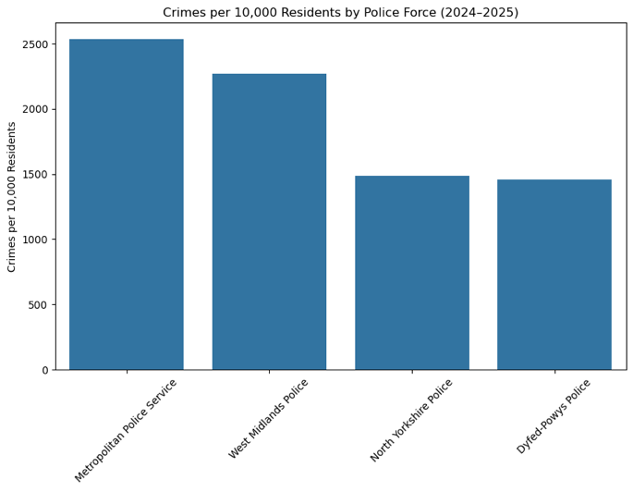
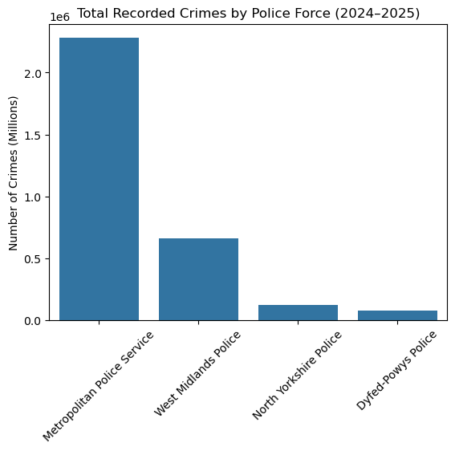
The first step of this analysis was to examine the total number of crimes recorded over the full 24 months in each police force area. Figure 1 shows the Metropolitan Police Service Area reported by far the highest number of recorded crimes over the period, followed by West Midlands Police. North Yorkshire Police and Dyfed-Powys report significantly fewer incidents.
Figure 2 - Crimes per 10,000 by Police Force
Figure 1 - Total Crimes by Police Force
However, comparing total crime volume alone can be misleading due to the vastly differing populations for each of these regions. Areas with higher population will of course have more recorded crimes. Therefore, it was decided that approximate population data would be included in the analysis. Figure 2 shows the crimes recorded adjusted per 10,000 residents. While the difference becomes less extreme, the overall ranking remains the same. Urban police forces still show higher rates than rural forces when adjusted for population.

Crime Type Distribution
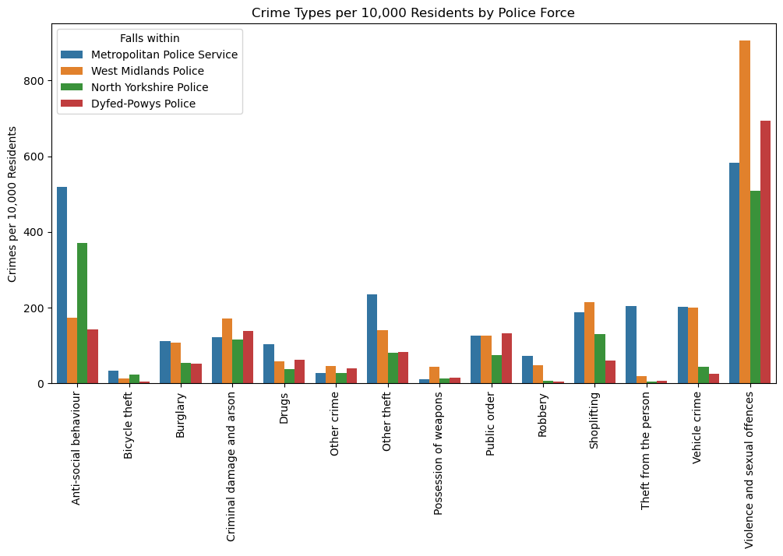
To enable fair comparison between regions with vastly different population sizes, crime type distributions were also examined using crimes per 10,000 residents. Examining the distribution of crime types in Figure 3 reveals that violence and sexual offences represent the largest proportion of recorded crimes across all police forces. Anti-social behaviour is the second most common category however, West Midlands Police and Dyfed-Powys Police report significantly less incidents than the Metropolitan Police Service and North Yorkshire Police.
Figure 3 - Crime Type Distribution per 10,000 Residents by Police Force
While the general pattern of crime types is broadly similar across regions, there are a few key findings. In theft categories (specifically ‘Theft from the person’ and ‘Other theft’) the Metropolitan Police area reports vastly more incidents than the other forces. As well as this ‘Vehicle crime’ shows many more reports in the two urban areas when compared with the rural areas even when adjusted for population.
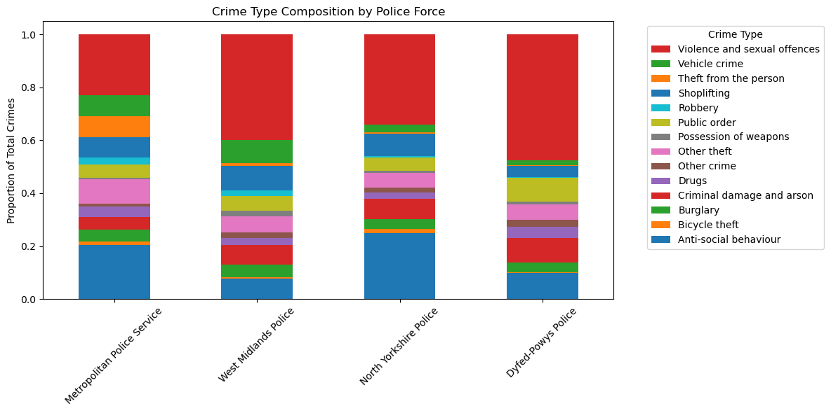
Examining the proportional composition of crime types in Figure 4 reveals that violence and sexual offences make up a particularly large share of total crime in Dyfed-Powys and West Midlands Police. In contrast, urban forces such as the Metropolitan Police Service show a more diverse distribution of crime types, with a greater proportion of theft-related offences including shoplifting, theft from the person and other theft.
Figure 4 - Crime Type Composition per Police Force

Crime trends over time
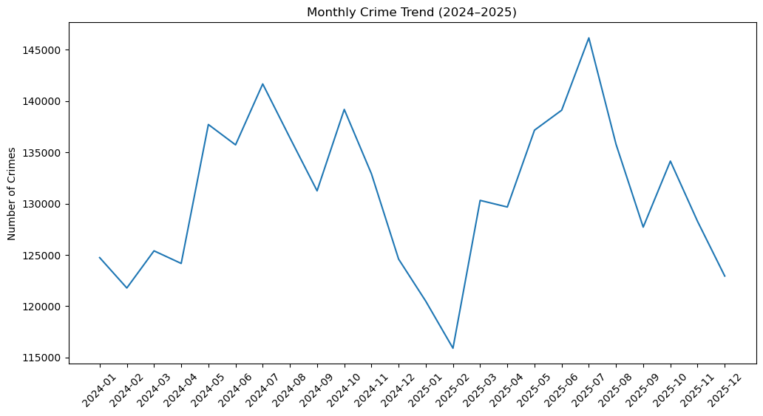
To explore how crime levels change over time, monthly crime totals were analysed across the full dataset (all forces) across the full period (Jan 2024 – Dec 2025). The overall trend in Figure 5 shows noticeable fluctuations throughout the year, with crime levels generally increasing during the late spring and peaking in the summer months before declining towards the winter period. These seasonal fluctuations may be associated with increased social activity and more people being outdoors during the warmer months.
Figure 5 - Monthly Crime Trend
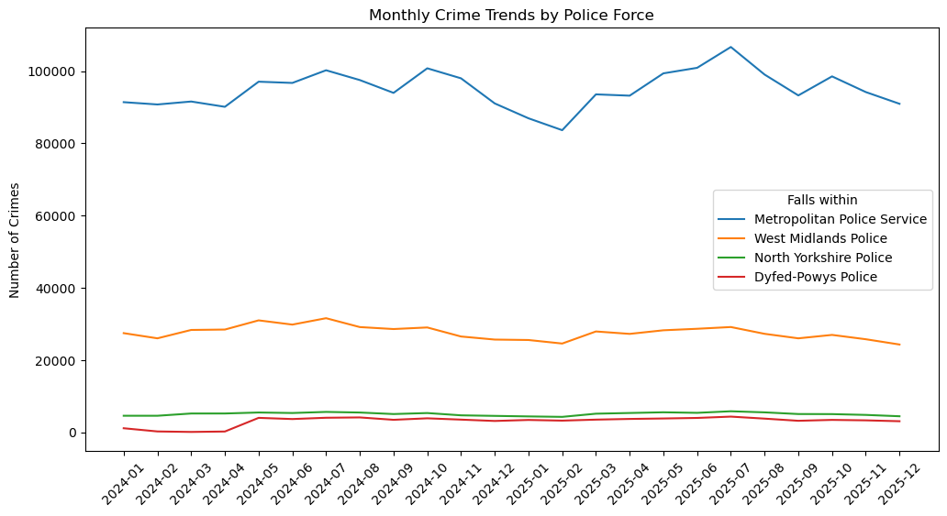
When examining monthly crime trends by police force in Figure 6, a similar season pattern can be observed across all regions. The Metropolitan Police Service consistently records the highest number of crimes each month, followed by West Midlands Police, while North Yorkshire Police and Dyfed-Powys Police record significantly lower totals.
Figure 6 - Monthly Crime Trends by Police Force

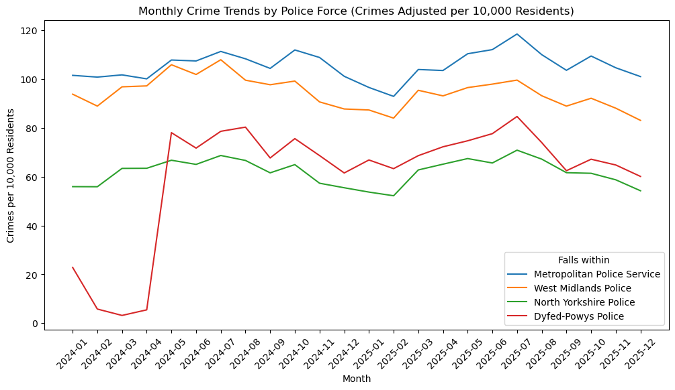
The differences between crime totals largely reflect the population size of each region covered by the police force. So, to allow for fair comparison between regions with different population sizes, crime trends were also analysed using crimes per 10,000 residents. In Figure 7 even after adjusting for population, the same general pattern remains. The Metropolitan Police Service shows the highest crime rate throughput the period, followed by West Midlands Police, with North Yorkshire Police and Dyfed-Powys Police displaying a lower crime rate overall.
Figure 7 - Monthly Crime Trends per Police Force (Population Adjusted)
The seasonal fluctuations remain visible after adjusting for population, which suggest that similar factors influence crime trends across all regions.

Urban vs Rural
To further explore regional differences, the police forces were grouped into urban and rural categories. The urban areas include the Metropolitan Police Service and West Midlands Police, while rural areas include North Yorkshire Police and Dyfed-Powys Police.
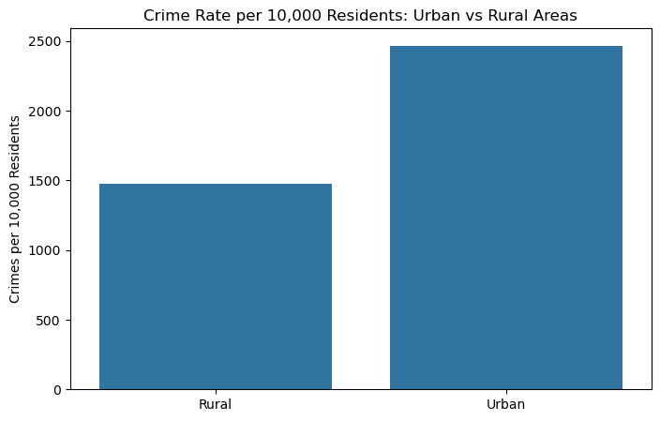
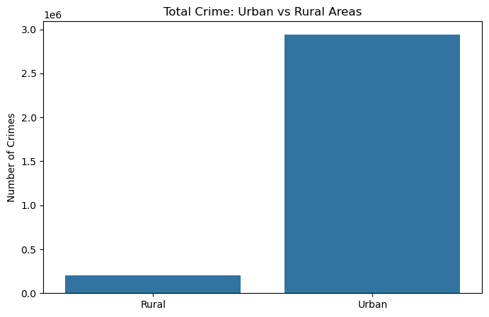
The comparison shows that urban regions experience a significantly higher volume of crimes in Figure 8 and even after adjusting for population in Figure 9 this remains consistent. This finding aligns with expectations, as urban areas have a higher population density, more activity and allow more opportunities for crimes to occur. Rural regions, while covering a greater area, generally experience lower crime rates due to lower population density and fewer high traffic environments that make some crime types more easily performed.
Figure 8 - Urban vs Rural Crime per 10,000
Figure 9 - Urban vs Rural Crime

Geographic Distribution of Crimes
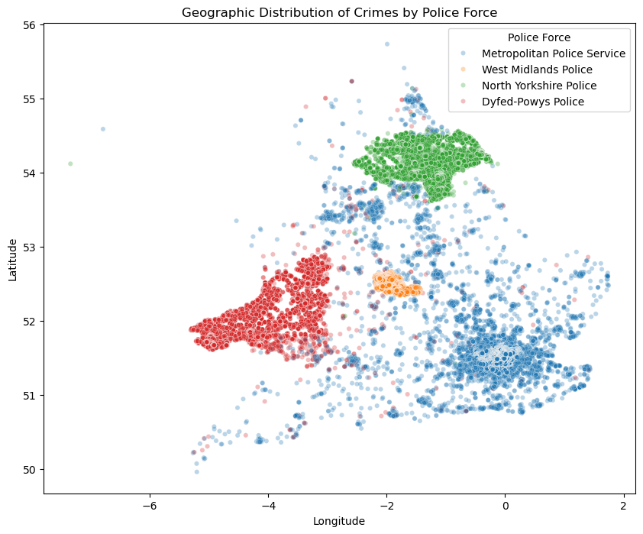
To explore the spatial distribution of crime incidents, the geographic coordinates of each crime were plotted by police force area, as shown in Figure 10. This visualisation provides insight into how crime locations are distributed across the regions covered by each police force.
Figure 10 - Crime Distribution Map
Clear clustering patterns appear that correspond closely with major population centres. The Metropolitan Police Service shows the densest clustering of crime incidents around London, reflecting the high population density and urban environment. Similarly, West Midlands Police show a dense cluster of incidents around the Birmingham area. These patterns are consistent with expectations, as urban environments typically experience higher crime volumes.
In contrast, North Yorkshire Police and Dyfed-Powys Police show a much more even dispersion of crime locations. Incidents show a generally even density throughout with no major crime hotspots. There are however a few smaller clusters that correspond with town centres. This reflects the mostly rural nature of these regions where population is more widely distributed, and population density is significantly lower.
The visualisation also reveals that some crimes recorded under the Metropolitan Police Service appear very far from the main London cluster, with several points located considerably further north or south. This may reflect limitations within the open crime dataset, where location coordinates are occasionally generalised or anonymised to protect privacy. While these points extend beyond the primary metropolitan cluster, the overall spatial pattern remains clear, with many incidents concentrated within the Greater London area.

Key Findings
This section summarises the most important insights from the analysis.
- Violence and sexual offences is the most common crime category across all regions.
- Urban police forces experience higher crime rates than rural areas even once adjusted for population. The Metropolitan Police Service consistently shows the highest crime rate per 10,000 residents.
- Crime occurrences exhibit seasonal patterns, with incidents generally increasing during the late spring and summer months and declining during the winter period.
- Theft related crimes are much more common in urban areas, particularly theft from the person and vehicle crime.
- The crime map shows strong clustering of crimes around major cities and towns, particularly London and Birmingham, while rural regions show a more dispersed crime pattern.
These findings highlight clear differences between urban and rural policing environments and provide a foundation for further analysis of selected forces.

Recommendation
Based on the findings of this analysis, the two forces recommended for further analysis are the Metropolitan Police Service and the Dyfed-Powys Police.
The Metropolitan Police Service represents the largest and most densely populated area in the dataset. It consistently records the highest number of crimes as well as the highest crime rates when adjusted for population. As London is the largest property market in the UK, understanding the distribution and composition of crime within this region is particularly valuable for real estate decision making. More deeply analysing crime patterns within this region may help identify specific areas and neighbourhoods where crime levels could influence property demand.
In contrast, Dyfed-Powys Police covers a predominantly rural region with a significantly lower population density and lower overall crime rates. The distribution of crimes is also much more dispersed, reflecting the rural nature of the region. Areas with lower crime rates may attract opportunities for residential development or properly investment, particularly for buyers seeking quieter environments.
Selecting these two police forces provides a useful comparison between a major urban property market and rural region with significantly lower crime levels. This contrast allows space for further investigation into how crime patterns may influence properly interest across different types of regions.

Reflection
This project demonstrates how modern analytical tools can improve the efficiency of data analysis workflows. AI tools were used to assist with technical tasks such as generating code snippets for data cleaning, creating visualisations and troubleshooting bugs and errors.
However, the analytical direction of the project (selection of variables, design of visualisations and interpretation of results) was done independently. AI was therefore used as a supporting tool to accelerate technical implementation, allowing more time to be focused on interpreting the data and making valuable insights and recommendations from it.

References
Population data obtained from:
https://www.met.police.uk/
https://www.westmidlands.police.uk/police-forces/west-midlands-police/areas/about-us/about-us/our-people/our-structure/
http://hmicfrs.justiceinspectorates.gov.uk/police-forces/north-yorkshire/more-about-this-area/
https://www.dyfed-powys.police.uk/police-forces/dyfed-powys-police/areas/about-us/about-us/who-we-serve-and-where/

